

Semester One Examination, 2022

Question/Answer booklet

MATHEMATICS  
METHODS  
UNIT 1

Section Two:  
Calculator-assumed

**Student Name**

**Teacher Name**

|  |  |
| --- | --- |
| Number of additional answer booklets used (if applicable): |  |

## Time allowed for this section

Reading time before commencing work: ten minutes

Working time: one hundred minutes

## Materials required/recommended for this section

***To be provided by the supervisor***

This Question/Answer booklet

Formula sheet (retained from Section One)

***To be provided by the candidate***

Standard items: pens (blue/black preferred), pencils (including coloured), sharpener,  
correction fluid/tape, eraser, ruler, highlighters

Special items: drawing instruments, templates, notes on two unfolded sheets of A4 paper, and up to three calculators, which can include scientific, graphic and Computer Algebra System (CAS) calculators, are permitted in this ATAR course examination

## Important note to candidates

No other items may be taken into the examination room. It is **your** responsibility to ensure that you do not have any unauthorised material. If you have any unauthorised material with you, hand it to the supervisor **before** reading any further.

## Structure of this paper

|  |  |  |  |  |  |
| --- | --- | --- | --- | --- | --- |
| Section | Number of questions available | Number of questions to be answered | Working time (minutes) | Marks available | Percentage of examination |
| Section One: Calculator-free | 7 | 7 | 50 | 52 | 35 |
| Section Two: Calculator-assumed | 12 | 12 | 100 | 98 | 65 |
|  | | |  | **Total** | 100 |

## Instructions to candidates

1. The rules for the conduct of examinations are detailed in the school handbook. Sitting this examination implies that you agree to abide by these rules.

2. Write your answers in this Question/Answer booklet preferably using a blue/black pen.  
Do not use erasable or gel pens.

3. You must be careful to confine your answers to the specific question asked and to follow any instructions that are specific to a particular question.

4. Show all your working clearly. Your working should be in sufficient detail to allow your answers to be checked readily and for marks to be awarded for reasoning. Incorrect answers given without supporting reasoning cannot be allocated any marks. For any question or part question worth more than two marks, valid working or justification is required to receive full marks. If you repeat any question, ensure that you cancel the answer you do not wish to have marked.

5. It is recommended that you do not use pencil, except in diagrams.

6. Supplementary pages for planning/continuing your answers to questions are provided at the end of this Question/Answer booklet. If you use these pages to continue an answer, indicate at the original answer where the answer is continued, i.e. give the page number.

7. The Formula sheet is not to be handed in with your Question/Answer booklet.

Section Two: Calculator-assumed 65% (98 Marks)

This section has**twelve** questions. Answer **all** questions. Write your answers in the spaces provided.

Working time: 100 minutes.

Question 8 (8 marks)

(a) The variables $V$ and $t$ are linearly related so that when $t=3, V=51$ and when $t=4, V=68$ 
. State, with reasoning, whether the relationship between $V$ and $t$ is an example of direct proportion. (2 marks)

(b) Four points have coordinates $A\left(-11, 7\right), B\left(4, -3\right), C\left(7, 9\right)$ and $D\left(s, t\right)$.

(i) If $B$ is the midpoint of $A$ and $D$, determine the value of the constant $s$ and the value of the constant $t$. (2 marks)

(ii) Determine the equation of the line that is perpendicular to $AB$ and that passes through $C$ in the form $ax+by+c=0$, where $a, b$ and $c$ are integers and $a>0$.

(4 marks)

Question 9 (7 marks)

A circle has equation $x^{2}+y^{2}+4x-6y=36$.

(a) Determine the centre and radius of the circle. (3 marks)

Points $S$ and $T$ lie on the circle above such that the origin is the midpoint of $ST$. The line through the centre of the circle to the origin is perpendicular to $ST$.

(b) Show that $ST$ has a length of $12$ units. (4 marks)

Question 10 (8 marks)

Triangle $ABC$ has sides $a=17.2$ cm, $c=21.6$ cm and an area of cm2.

(a) Determine all possible values for the size of angle $B$. (3 marks)

(b) Determine, showing use of trigonometry, the largest possible perimeter of triangle $ABC$.

(3 marks)

(c) Determine, showing use of trigonometry, the size of angle $A$ when triangle $ABC$ has the largest possible perimeter. (2 marks)

Question 11 (9 marks)

The time of sunrise, $t$ hours after midnight, on the $n^{th}$ day of the year in Esperance is closely modelled by

$$t=6.27-1.71\sin\left(0.0172n+2.083\right).$$

(a) Use the model to calculate, in hours and minutes, the time of sunrise on $5$ February.

(2 marks)

(b) Graph $t$ as a function of $n$ on the axes below for $0≤n≤365$. (4 marks)

<EFOFEX>
id:fxd{3998a146-79aa-4577-a258-f77eab036372}

FXData:

</EFOFEX>

(c) Jill lives in Esperance and is woken by her alarm clock at $6:12$ am every day. How many days will she be awake before sunrise in a year of $365$ days? (3 marks)

Question 12 (3 marks)

The graph below shows information about prisms with the same volume.

<EFOFEX>

id:fxd{3f485b05-9464-42f3-b880-f4c2b82f8d1a}


FXData:

</EFOFEX>

(a) Give **one** example to show that the volume is 24 cm3. (1 mark)

The equation of the graph is $A×l=c$, where $c$ is a constant.

(b) Determine the value of $c$. (1 mark)

(c) Circle the correct statement. (1 mark)

|  |  |
| --- | --- |
| $l$ is directly proportional to $A$ | $l$ is directly proportional to $\frac{1}{A}$ |
| $l$ is inversely proportional to $\frac{1}{A}$ | $A$ is directly proportional to $l$ |

Question 13 (9 marks)

A function defined by $f\left(x\right)=\begin{matrix}a \\ \overline{x+b}\end{matrix}$, where $a$ and $b$ are constants, passes through the points $(-8, 0.2)$ and $(2, -0.6)$.

(a) Determine the value of $a$ and the value of $b$. (3 marks)

(b) Draw the graph of $y=f(x)$ on the axes below, clearly indicating the coordinates of all axes intercepts and equations of any asymptotes. (4 marks)

<EFOFEX>
id:fxd{5f4ee561-bb00-43cc-9604-83a9e68772d7}

FXData:

</EFOFEX>

(c) State the equations of all asymptotes of the graph of $y=f\left(2x\right)-3$. (2 marks)

Question 14 (9 marks)

<EFOFEX>
id:fxd{3c76c829-f4eb-462d-ae04-5a6ee54b0117}

FXData:
</EFOFEX>The shaded regions shown in the diagram form  
a logo that is to be cut from a plastic sheet.  
  
The boundaries of the shaded regions are  
parts of triangle $XOY$, where $∠XOY=132°$,  
and arcs of two concentric circles with  
centre $O$ and radii of $32$ cm and $82$ cm.

(a) Express $132°$ exactly in radians. (1 mark)

(b) Determine the total length of the two curved and three straight cuts that must be made by the cutting machine, giving your answer to the nearest centimetre. (4 marks)

(c) Determine the area of the logo, giving your answer to the nearest square centimetre.

(4 marks)

Question 15 (10 marks)

The diagram below shows the points $O(0,0)$, $M(3+t, 0)$ and , for .

<EFOFEX>

id:fxd{9dbdef82-ec48-4c54-8454-e54fda0d2aab}


FXData:

</EFOFEX>

(a) Show that the area, $A$, of the triangle is $A=\frac{21}{2}+2t-\frac{t^{2}}{2}$. (2 marks)

(b) Draw a graph of $A$ for $0≤t≤7$, on the axes below, clearly labelling all intercepts  
and turning point. (2 marks)

<EFOFEX>

id:fxd{cc2e3080-f104-4809-af6d-73016b177713}


FXData:


</EFOFEX>

(c) (i) What feature of the graph in part (b) allows you to determine the value of $t$ that  
maximises the area? (1 mark)

(ii) State the value of $t$ that maximises the area, and state what is this area. (2 marks)

Given $t=2$, the diagram at the top of page 10 is extended to form a square $MNPQ$.

The four vertices of the square lie on the axes as shown below.

<EFOFEX>

id:fxd{1f8cbc17-7870-4c00-bcea-f371ff8f2b67}


FXData:


</EFOFEX>

(d) (i) Determine the equation of the line $PQ$, which is parallel to $MN$. (2 marks)

(ii) Determine the area of the square $MNPQ$. (1 mark)

Question 16 (8 marks)

(a) The graph of the quadratic function $y=f(x)$ has roots at $x=-7$ and $x=3$ and the range of $f(x)$ is $y≤50$. Use an algebraic method to determine $f(0)$. (4 marks)

(b) The area of square is cm2 more than six times the area of square $A$. The difference in the perimeters of the two squares is $98$ cm. Determine the least possible area of square $A$, the smaller of the squares. (4 marks)

Question 17 (10 marks)

(a) A pilot flies a plane on course to land at Perth Domestic Airport $645$ km away. Unfortunately, due to an error, her bearing is out by $2$ °. After travelling $730$ km she

realises she is off course. How far from the airport is the plane? (3 marks)

(b) Find the area of the triangle shown in the diagram below (not to scale). (2 marks)

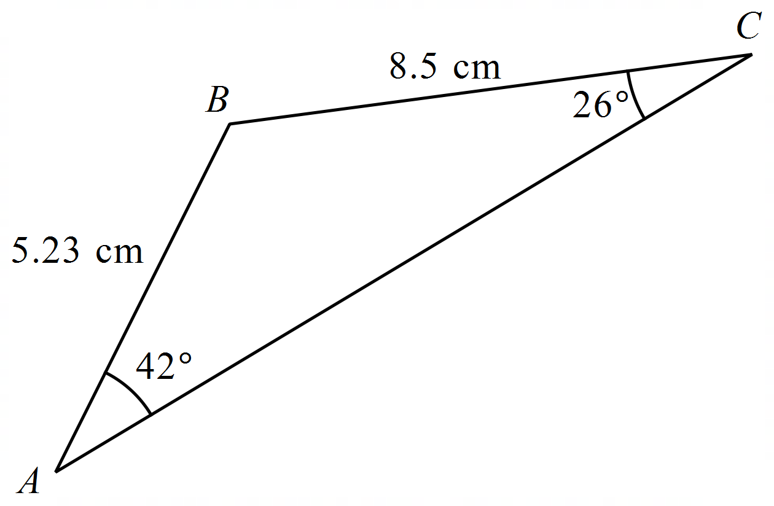

(c) Barbara and Leo are geologists who start walking from a mine ($M$) in two different directions. Barbara walks for 17 km to a marked beacon on a hill ($H$). Leo walks in a straight line towards a temporary camp ($C$). The angle $HMC$ is 48°. When Barbara reaches the beacon ($H$), she is 13.5 km from the camp ($C$). Given that angle $MCH$ is obtuse, how far does Leo have to walk to reach the camp? (5 marks)

Question 18 (7 marks)

A group of $4$ students is needed to assist in the school office. The group is to be selected from a class of $16$, in which $5$ are boarders and the remainder day students.

(a) Determine the number of different groups that can be selected. (1 mark)

(b) Determine the number of different groups that can be selected containing only boarders.

(1 mark)

(c) Determine the number of different groups that can be selected containing no boarders.

(2 marks)

(d) Determine the number of different groups that can be selected containing at least one boarder and at least one day student. (3 marks)

Question 19 (10 marks)

The graph of the cubic polynomial $y=f(x)$ passes through the points $(-1, 0)$, $(0, 9)$ and has a local minimum at $(3, 0)$.

(a) Use the above information to sketch the graph of $y=f(x)$ on the axes below. (3 marks)

<EFOFEX>
id:fxd{28bfd811-fc5a-4c01-8fa9-502cedf5a0f1}

FXData:

</EFOFEX>

Let , where $b, c$ and $d$ are constants.

(b) Determine the value of each of the constants $b, c$ and $d$. (3 marks)

(c) Another cubic polynomial is defined by $g\left(x\right)=x^{3}-6x^{2}+ax+5$. Determine the value(s) of the constant $a$ so that the graphs of $y=f\left(x\right)$ and $y=g(x)$ do not intersect. (4 marks)

Supplementary page

Question number: _________

Supplementary page

Question number: _________

|  |  |  |  |
| --- | --- | --- | --- |
| Markers | Markers use only | | |
| Question | Maximum | Mark |
| Ms Mack  (23 marks) | 8 | 8 |  |
| 9 | 7 |  |
| 10 | 8 |  |
| Miss Leow  (21 marks) | 11 | 9 |  |
| 12 | 3 |  |
| 13 | 9 |  |
| Mrs Gatland (19 marks) | 14 | 9 |  |
| 15 | 10 |  |
| Ms Thompson (18 marks) | 16 | 8 |  |
| 17 | 10 |  |
| Mrs Kalotay (17 marks) | 18 | 7 |  |
| 19 | 10 |  |
|  | S2 Total | 98 |  |

© 2022 WA Exam Papers. Willetton Senior High School has a non-exclusive licence to copy and communicate this document for non-commercial, educational use within the school. No other copying, communication or use is permitted without the express written permission of WA Exam Papers. SN115-192-2.